**REDUCING CARBON FOOT-PRINT BY OPTIMIZING IOT DEVICE USAGE**

## A PROJECT REPORT

## Submitted by,

## Challa Shalini - 20211CIT0164

**Venkat Navya S -20211CIT0042**

**Pathakamuri Durga Prasheena -20211CIT0166**

**Chavva Rajeswari -20211CIT0170**

### Under the guidance of,

**Dr. Mohana S D**

**in partial fulfillment for the award of the degree of**

**BACHELOR OF TECHNOLOGY**

**IN**

**COMPUTER SCIENCE AND ENGINEERING (INTERNET OF THINGS)**

 **At**

**PRESIDENCY UNIVERSITY**

**BENGALURU**

**JANUARY 2025**

**PRESIDENCY UNIVERSITY**

**SCHOOL OF COMPUTER SCIENCE ENGINEERING**

**CERTIFICATE**

This is to certify that the Project report **“REDUCING CARBON FOOT-PRINT BY OPTIMIZING IOT DEVICE USAGE”** being submitted by Challa Shalini bearing roll number “20211CIT0164”, Venkat Navya S bearing roll number “20211CIT0042”, P Durga Prasheena bearing roll number “20211CIT0166”, Chavva Rajeswari bearing roll number “20211CIT0170” in partial fulfillment of the requirement for the award of the degree of Bachelor of Technology in Computer Science and Engineering (Internet of Things) is a bonafide work carried out under my supervision.

|  |  |
| --- | --- |
| **Dr. Mohana S D**  Assistant Professor,  School of CSE&IS,  Presidency University | **Dr. Anandaraj S P**  Professor & HoD,  School of CSE,  Presidency University |

|  |  |  |
| --- | --- | --- |
| **Dr. L. SHAKKEERA**  Associate Dean,  School of CSE,  Presidency University | **Dr. MYDHILI NAIR**  Associate Dean,  School of CSE,  Presidency University | **Dr. SAMEERUDDIN KHAN**  Pro-Vc School of Engineering,  Dean -School of CSE&IS,  Presidency University |

**PRESIDENCY UNIVERSITY**

**SCHOOL OF COMPUTER SCIENCE ENGINEERING**

**DECLARATION**

We hereby declare that the work, which is being presented in the project report entitled **REDUCING CARBON FOOT-PRINT BY OPTIMIZING IOT DEVICE USAGE** in partial fulfillment for the award of Degree of **Bachelor of Technology** in **Computer Science and Engineering (Internet of Things)**, is a record of our own investigations carried under the guidance of **Dr.Mohana S D, Assistant Professor,** **School of Computer Science Engineering & Information Science, Presidency University, Bengaluru.**

We have not submitted the matter presented in this report anywhere for the award of any other Degree.

**NAME ROLL NUMBER SIGNATURE**

**Challa Shalini 20211CIT0164**

**Venkat Navya S 20211CIT0042**

**Pathakamuri Durga Prasheena 20211CIT0166**

**Chavva Rajeswari 20211CIT0170**

**ABSTRACT**

The rapid adoption of Internet of Things (IoT) devices has transformed industries by improving connectivity, automation, and data-driven decision-making. However, the expanding scale of IoT networks raises concerns about their environmental impact, particularly in terms of energy consumption and carbon emissions. This paper explores strategies to reduce the carbon footprint of IoT devices by enhancing their energy efficiency throughout their lifecycle.

Key strategies discussed include energy-efficient hardware design, dynamic power management, adaptive communication protocols, and edge computing. By implementing low-power modes and processing data closer to the source, these methods can significantly reduce energy use and emissions associated with cloud processing. Optimizing device deployment and operation can also extend device lifespan, thereby reducing waste and energy demands linked to production and disposal. Additionally, integrating renewable energy sources into IoT infrastructure offers an opportunity to further lower the carbon footprint.

The study concludes that while IoT devices increase energy demand, targeted optimizations can substantially reduce energy consumption and carbon emissions without compromising performance. Manufacturers and organizations should prioritize energy-efficient designs and strategies, while policymakers can encourage these practices through regulations and incentives. Optimizing IoT usage ultimately helps reduce the carbon footprint of digital technologies and supports efforts to mitigate climate change.

**ACKNOWLEDGEMENT**

First of all, we indebted to the **GOD ALMIGHTY** for giving me an opportunity to excel in our efforts to complete this project on time.

We express our sincere thanks to our respected dean **Dr. Md. Sameeruddin Khan**, Pro-VC, School of Engineering and Dean, School of Computer Science Engineering & Information Science, Presidency University for getting us permission to undergo the project.

We express our heartfelt gratitude to our beloved Associate Deans **Dr. Shakkeera L and Dr. Mydhili Nair,** School of Computer Science Engineering, Presidency University, and Dr. “**Dr. Anandaraj S P**, Head of the Department, School of Computer Science Engineering, Presidency University, for rendering timely help in completing this project successfully.

We are greatly indebted to our guide **Dr. Mohana S D, Assistant Professor** and Reviewer **Dr. Syed Siraj Ahmed, Associate Professor**, School of Computer Science Engineering & Information Science, Presidency University for his inspirational guidance, and valuable suggestions and for providing us a chance to express our technical capabilities in every respect for the completion of the project work.

We would like to convey our gratitude and heartfelt thanks to the PIP2001 Capstone Project Coordinators **Dr. Sampath A K, Dr. Abdul Khadar A and Mr. Md Zia Ur Rahman,** department Project Coordinators **Dr. Sharmasth Vali Y** and Git hub coordinator **Mr. Muthuraj.**

We thank our family and friends for the strong support and inspiration they have provided us in bringing out this project.

**Challa Shalini**

**Venkat Navya S**

**Durga Prasheena**

**Chavva Rajeswari**

**LIST OF TABLES**

|  |  |  |  |
| --- | --- | --- | --- |
| **Sl. No.** | **Table Name** | **Table Caption** | **Page No.** |
| 1 | Table 2.1 | Literature Survey | 15-19 |

**LIST OF FIGURES**

|  |  |  |  |
| --- | --- | --- | --- |
| **Sl. No.** | **Figure Name** | **Figure Caption** | **Page No.** |
| 1  2  3  4  5  6  7  8  9  10  11  12 | Figure 6.1  Figure 7.1  Figure 9.3.1  Figure 9.3.2  Figure 9.3.3  Figure 9.3.4  Figure 9.3.5  Figure 9.3.6  Figure 9.3.7  Figure 9.3.8  Figure 9.3.9  Figure 9.3.10 | System Design  Gantt Chart  Confusion Matrix of Random Forest Classifier  Classification Report of RandomForest Classifier  Confusion Matrix of Decision Tree Classifier  Classification Report of Decision Tree Classifier  Confusion Matrix of XGBoost Classifier  Classification Report of XGBoost Classifier  Confusion Matrix of SVC Model  Classification Report of SVC Model  Inputs  Output | 30  31  40  40  40  41  41  41  41  41  42  42 |

**TABLE OF CONTENTS**

|  |  |  |
| --- | --- | --- |
| **CHAPTER NO.** | **TITLE** | **PAGE NO.** |
|  | **ABSTRACT**  **ACKNOWLEDGEMENT** | **iv**  **v** |
| **CHAPTER 1.** | **INTRODUCTION**   * 1. **Background**   2. **Project Overview**      1. **Current Industry Challenges**      2. **Problem Statement**   3. **Project Objectives**   4. **Project Scope**   5. **Advantages** | **10**  **11**  **11**  **11**  **12**  **12**  **13**  **13** |
| **CHAPTER 2.** | **LITERATURE REVIEW** | **15** |
| **CHAPTER 3.** | **RESEARCH GAPS AND EXISTING METHODS** | **20** |
| **CHAPTER 4.** | **PROPOSED METHODOLOGY**  **4.1 Random Forest Classifier**  **4.2 Decision Tree Classifier**  **4.3 XGBoost Classifier**  **4.4 SVC Model** | **22**  **22**  **23**  **23** |
| **CHAPTER 5.** | **OBJECTIVE** | **24** |
| **CHAPTER 6.** | **SYSTEM DESIGN AND IMPLEMENTATION** | **27** |
| **CHAPTER 7.** | **TIMELINE FOR EXECUTION** | **31** |
| **CHAPTER 8.** | **OUTCOMES** | **32** |
| **CHAPTER 9.** | **RESULTS AND DISCUSSIONS**  **9.1 Outcome of Optimization Method**  **9.1.1 Optimization of Energy Efficiency of IoT Devices**  **9.1.2 Smart IoT Devices Deployment**  **9.2 Optimization Approach Outcomes**  **9.2.1 Improving Energy Efficiency of IoT Devices**  **9.2.2 Smart IoT Devices Deployment**  **9.2.3 Optimization of Data Transmission**  **9.2.4 Integration of Renewable Sources of Energy**  **9.3 Discussion** | **35**  **35**  **35**  **36**  **37**  **37**  **37**  **37**  **38**  **39** |
| **CHAPTER 10.** | **CONCLUSION** | **43** |
| **CHAPTER 11.** | **REFERENCES** | **46** |
| **APPENDIX-A** | **PSEUDOCODE** | **49** |
| **APPENDIX-B** | **SCREENSHOTS** | **52** |
| **APPENDIX-C** | **ENCLOSURES** | **53** |

**CHAPTER-1**

**INTRODUCTION**

The Internet of Things is that vibrant worldwide growth of devices that has transformed the business, home, and city fronts in search of network development, automation, and the preparation of real-time information. But as exponentially more IoT devices pour into existence, so does their natural impact. It is an irony, though, that IoT devices-inherently compact and efficient-proposes to hit the carbon footprint of this earth significantly through energy consumption, production patterns, and generating more waste in the environment. These devices continuously function, taking a great deal of control just to keep connectivity and process data and thereby they would consume higher amounts of nursery gas emissions. Add to these the fact that production and shipping out such IoT devices lead to asset depletion and electronic wastes, which also contributes to their footprint on the environment.  
Now, with the world entering the global climate crisis, it is time to optimize the IoT frameworks in reducing the carbon footprint of IoT devices. Optimization in this way will ensure a bright future concerning the aspect of maintainability because it is trailing advanced innovation and procedures for the objective of improving energy efficiency, extending the lifecycle of devices, and minimizing waste. Energy-efficient equipment transmission; adaptation of low-power communication protocols; linking renewable sources of energy are sure means of conserving the usage of energy. For example, edge computing can better prepare information by reducing its dependence on energy-intensive cloud administrations through localized analysis of information.

The establishment of feasible practices in manufacture and the rendering reuse, recycle, and responsible transportation of IoT devices is another important dimension of optimization. For instance, a design of measurable quality and repairability can minimize environmental impacts that arise from obsolescence-quality of gadgets. Predictive support based on AI-based can be employed for monitoring the performance of the gadgets; therefore, the unwanted replacement will be repaired before it is actually disposed of.

This will shift the biological system of IoT from being a contributor to natural degradation to becoming the hub of economic development. Attainment of optimization as a prime objective will go hand in hand with broader changes in its structuring to enhance the performance and life cycle of the IoT device; greater efforts will be aimed at combating climate change. This presentation puts emphasis on how important and promising this reduction in carbon footprint is for IoT devices and also adds emphasis on this section where mechanical advancement plays a role in achieving an economical future. Many devices for the Internet of Things (IoT) rely on electricity to function, but some devices harvest their resources. As a world, both IoT and AI offer new possibilities that will help us use energy storage, increase energy production, and reduce our cumulative carbon emissions.

* 1. **Background**

The rapid growth in IoT devices has changed the industries, but the increased energy consumption and carbon emissions throughout their lifecycle are concerns. Inefficient operations, like continuous running during low-demand periods, increase energy waste and environmental impact. This project addresses these challenges by leveraging software-based optimization techniques such as dynamic scheduling, power management, and data reduction to improve energy efficiency without compromising functionality. This reduces the costs of operation, and it supports the global sustainability goals. It makes way for industries and the policy makers to adopt an IoT system that's environmentally responsible with reduced energy consumption for IoT.

* 1. **Project Overview**

This is an energy optimization usage project with the help of software that reduces the carbon footprint of IoT. The emission of greenhouse gases in such devices is due to bad operation and large lifecycle demands. Therefore, this will be one of the most critical contributions of energy consumption with the IoT. These energy efficiency techniques would increase based on the implementation of dynamic scheduling, power management, and decrease of data. It will develop awareness among companies working in industrial and large scale for the environment-friend IoT usages along the way leading these sectors with its application of services toward completing sustainable global vision missions.

* + 1. **Current Industry Challenges**
* **High Energy Consumption:** The IoT devices along with supporting infrastructures consume a lot of energy, so their operation cost is high and thus its environmental effects.
* **Nonuniform Standards:** With no standard on energy efficiency, the optimization varies inconsistently for every device.
* **Idle and Redundant Operations:** Operations keep on running through the off-peak hours as long as data duplication processes keep consuming energy.
* **Integration Problem:** In most scenarios, these sophisticated applications for energy optimization are incompatible with the ancient IoT systems.
* **Data Privacy Issues:** Optimizations may include processing real-time data, and this process can be risky to a privacy issue or some security issues.
* **Cost Barriers:** Developing the initial and improving over time the system is too costly to adopt more of it.
* **Scalability:** It is challenging to scale the energy optimization solution with the number of IoT deployments.
  + 1. **Problem Statement**

The quality of the atmosphere is further getting deteriorated as the rate of the increase in resource consumption is matching that of population. Because of this enormous consumption of resources, the actual consumption can't be traced by the existing buildings and infrastructures, which results in limiting this energy usage in an insignificant manner. This consequently leads to emitting immense carbon dioxide, and it indicates that carbon footprints are rising. It follows that innovation has grown quite relevant in the context of optimization and usage of energy besides reducing carbon footprints. Based on this fact, it seeks to provide an assessment framework as part of a blueprint of an IoT-enabled green technology to meet the deficiencies under current mechanisms for tracing emission of carbon and thereafter the reduction in buildings. The research reveals that the carbon footprint has reduced to over 22% from traditional buildings considering electrical and LPG consumption over a specified time due to the impact of such technologies.

* 1. **Project Objectives**
* **To use the full potential of an IoT device:** All the available application development using full-fledged work by all those IoT devices so as to eliminate every single idle and wasteful energy.
* **Energy Saving Features:** Dynamic scheduling and power management protocols can be utilized in minimizing the use of energy without hampering the operation of the devices
* **Reduction in Data Energy:** With the data reduction concept, the excess use of energy due to data transmission and processing is minimized
* **Scalable Energy Systems:** Improve the efficiency of IoT networks inter-device and between infrastructures intercommunication.
* **Scalable Solutions Supporting Large-Scale Deployments:** Develop scalable solutions for large ecosystems of IoT in smart cities or industrial IoT deployments.
* **Contribute to Sustainability Efforts:** Align your project with world sustainability efforts as a carbon reduction project for IoT technologies.
* **Enable Plug-and-Play Integration:** Maximize adoption and impact by providing seamless integration capabilities with existing IoT devices and systems.
* **Resource Efficiency:** Promote the usage of energy-efficient IoT solutions that foster adoption in both the industrial and consumer segments.
  1. **Project Scope:**

**In Scope:**

* **Software Development for Power Optimization:** It refers to software development in the area of power management, dynamic scheduling, and data reduction aimed at reducing energy consumption from IoT devices.
* **Improving Efficiency on IoT Devices:** Smart home devices, health care-related applications, and industrial use cases will experience improvements in terms of energy efficiency.
* **Consistency with Other Systems:** It should be compatible with any other systems without requiring drastic alterations in the hardware.
* **Scalability:** Design software solutions that scale from small to large IoT deployments.
* **Impact Measurement:** Quantify energy savings and carbon footprint reduction toward sustainability goals.
* **Security and Privacy:** Implement strong data security during optimization.

**Out-of-Scope:**

* **Hardware Engineering:** No design or changes work of IoT hardware will be carried out in the Project.
* **IoT Industry Standards Development:** Sector-wide energy savings standards development is not included.
* 3.**End User's Training:** The project will exclude user education, and adoption-related work.
* **Non IoT Device Optimization Work:** Optimization on IoT devices; no optimization would be done to non-IoT equipment.
* It will not concentrate on the development of advanced AI or machine learning solution development.
  1. **Advantages:**

There have been a number of crucial benefits that the SIOEO project has uncovered. These diminish carbon footprints as it aims to maximize IoT device energy consumption. This, in turn, means that having the data monitoring in real-time along with the machine learning technique, maximizes the scope of increasing energy efficiency through proper consumption of power utilized by those IoT devices during their routine use. It reduces the use of resources and waste. Optimization in such a model saves businesses and people huge sums of money from electricity bills. Since it is scalable, it can be used across sectors like residential, commercial, and industrial settings. It enhances sustainability because it is implemented using eco-friendly practices that support the attainment of sustainability goals at the global level. As it prolongs the life cycle of IoT devices, minimizing e-waste by optimum usage, it promotes this vision. As it prolongs the life cycle of IoT devices, minimizing e-waste by optimum usage, it promotes this vision. It can be embedded into smart city infrastructures and therefore can enhance energy management in several IoT systems. Besides, the SIOEO model is useful for data-driven decision-making to optimize the use of resources and energy consumption. In general, this project promotes green IoT initiatives to create a more sustainable and energy-efficient technological environment. Since it stretches the lifespan of IoT devices, reducing e-waste by optimal usage, it promotes this vision. It can be integrated into smart city infrastructures and, therefore, enhance energy management in various IoT systems. Besides, the SIOEO model is beneficial for making data-driven decisions to optimize resource usage and consumption of energy. In general, this project promotes green IoT initiatives to make a more sustainable and energy-efficient technological environment.

**CHAPTER-2**

**LITERATURE SURVEY**

**Table 2.1: Literature Survey**

|  |  |  |  |  |  |  |  |
| --- | --- | --- | --- | --- | --- | --- | --- |
| Authors | Year | Dataset Used | Algorithms/Techniques | Methods | Merits | Demerits | Review |
| P. Asopa, P. Purohit, R. R. Nadikattu, P. Whig[14] | 2021 | IoT data from smart city sensors | IoT frameworks, carbon footprint models | Predictive energy optimization | Real-time monitoring, energy optimization | High costs, infrastructure, security concerns | Promotes sustainability but needs scalability analysis. |
| B. Johnson et al.[3] | 2020 | Smart Home Energy Dataset | Deep Learning (ANN) | Real-time monitoring and load forecasting | Improved accuracy of energy usage predictions by 30% | High computational cost | Demonstrated potential for real-time energy efficiency in smart homes. |
| C. Lee et al.[4] | 2021 | Public IoT Sensor Data | Clustering (K-Means) | Grouping devices based on energy usage patterns | Simplified device management | Limited to static clustering | Useful for initial classification but lacks adaptability. |
| D. Wang et al.[5] | 2018 | Industrial IoT Dataset | Reinforcement Learning | Adaptive energy optimization through reward-based learning | Dynamic adjustment to changing conditions | Requires extensive training data | Promising for large-scale industrial IoT networks. |
| E. Kumar et al.[6] | 2022 | Custom IoT Energy Dataset | Regression Analysis | Predictive maintenance for energy optimization | Reduced device failures and downtime | Limited to linear relationships | Effective for simpler IoT systems with minimal complexity. |
| F. Ahmed et al.[29] | 2019 | Open Smart Meter Data | Decision Trees | Rule-based optimization for energy efficiency | Easy implementation | Overfitting in complex systems | Suitable for straightforward IoT device setups. |
| H. Zhang et al.[27] | 2021 | Smart City IoT Data | Gradient Boosting Machines | Urban-scale IoT energy optimization | Enhanced scalability | Increased computational complexity | Demonstrated scalability for city-wide IoT networks. |
| I. Ali et al.[28] | 2017 | IoT Device Failure Dataset | Naïve Bayes | Predictive failure detection and energy optimization | Reduced device energy wastage | Low accuracy for large feature sets | Simple approach for failure-prone IoT setups. |
| J. Park et al.[9] | 2022 | Public IoT Sensor Data | Neural Networks | Intelligent control for energy efficiency | High adaptability to changing patterns | High training time | Suitable for dynamic IoT systems with complex patterns. |
| Zadeh, S. B. I., & Garay-Rondero, C. L.[30] | 2023 | Case studies on urban sustainability | Green supply chain measures, optimization tools | Explores sustainable urban logistics, green supply chain integration, and optimization | Promotes sustainability, efficient logistics | Implementation challenges in diverse cities | Comprehensive but needs real-world validations. |
| Amir Mosavi[15] | 2019 | Energy sector datasets | ANN, SVM, RF, regression models for energy prediction | Review of ML techniques for predicting energy consumption | Accurate forecasting, improved energy management | Dataset standardization challenges | Comprehensive but lacks focus on data integration. |
| Almalki, F.A., et al.[17] | 2023 | IoT Dataset | Green IoT frameworks, optimization | Energy usage classification and optimization | Promotes sustainability, reduces energy use | High cost, IoT security concerns | Promising but requires feasibility studies. |
| Kumar S, Boya R[[18] | 2012 | Open IoT Data | Virtualization, optimization | Green IT, energy-efficient frameworks | Reduces energy use, eco-friendly | High cost, scalability issues | Foundational for green cloud computing.. |
| Smith, J.D., & Jones, A.B.[10] | 2023 | Smart building data | ML (regression, ANN, SVM) | Energy optimization for buildings | Improves efficiency, real-time use | Privacy concerns, sensor needs | Effective but needs privacy solutions. |
| C. Lee et al.[7] | 2019 | Industrial IoT Dataset | Transfer Learning | Leveraging pre-trained models for energy optimization | Reduced training time | Dependence on pre-existing models | Effective for similar IoT setups with shared characteristics. |
| Islam et al.[1] | 2021 | Simulation Data | Weighted Proportional-Fair Scheduling | Resource scheduling with sleep mechanisms | Energy-efficient, cost-effective, eco-friendly | Requires practical implementation for validation | Proposed a renewable energy-based power supply architecture for off-grid HetNets. (arxiv.org) |
| Liu et al.[2] | 2019 | Simulated IoT Device Data | Cross-layer Optimization | Shifting energy consumption to cognitive mesh networks | Prolongs IoT device lifetime | Limited to specific network architectures | Introduced a cross-layer design to enhance IoT energy efficiency on edge devices. (arxiv.org) |
| Grinberg[19] | 2018 | N/A | Flask Framework | Web application development using Flask | Lightweight, flexible, easy to use | Limited to small to medium-sized applications | Discussed efficient web development using Python and Flask. (researchgate.net) |
| EpiSensor[20] | 2023 | Real-time Energy Data | IoT-enabled Energy Monitoring | Continuous monitoring and demand response | Immediate energy savings, grid stability | Implementation complexity | Explored carbon reduction strategies with IoT-enabled energy monitoring. (episensor.com) |
| AWS Architecture Blog[21] | 2021 | N/A | AWS IoT Services | Device property optimization | Minimizes environmental impact | Dependent on AWS ecosystem | Considered device properties influencing IoT devices' environmental footprint. (aws.amazon.com) |
| White Rose University[22] | 2022 | N/A | Python Flask | Digital twin operational platform development | Real-time system monitoring | Requires integration with existing systems | Developed a digital twin operational platform using Python Flask. (eprints.whiterose.ac.uk) |
| Solum ESL[23] | 2023 | N/A | IoT Devices | Smart device utilization | Reduces energy consumption and carbon emissions | Initial setup costs | Discussed how IoT helps minimize carbon footprint. (solumesl.com) |
| MicroEJ[24] | 2023 | N/A | Software Containers | Use of software containers in IoT devices | Limits carbon emissions, reduces resource usage | May require redesign of existing applications | Highlighted keys to more sustainable and profitable IoT devices. (microej.com) |
| Infopulse[25] | 2023 | N/A | IoT Energy Management | Real-time monitoring and optimization | Enhances energy efficiency, reduces environmental impact | Potential data privacy concerns | Examined IoT energy management benefits, use cases, and challenges. (infopulse.com) |
| Invisible Systems[26] | 2023 | N/A | IoT Sensors | Real-time monitoring, automation, optimization | Improves energy efficiency, reduces carbon footprint | Implementation costs | Discussed the role of IoT in reducing energy and carbon footprint. (invisible-systems.com) |

**CHAPTER-3**

**RESEARCH GAPS OF EXISTING METHODS**

One of the increasingly crucial challenges facing us today is the reduction in carbon footprint of IoT devices. However, enormous gaps in the ways we should optimize their usage still remain to be filled. Most of the solutions today generally relate to general power saving and do not consider the nature of IoT systems in dynamism. For instance, devices do not necessarily self-tune based on time-varying conditions like weather, or the data rate of communication required. This demands more intelligent algorithms, like possibly employing machine learning approaches that would predict and make the appropriate adjustments in the energy use based on real-time variability. Another important aspect we are missing with regard to IoT devices is taking care of the total lifecycle of IoT devices. Most of the current research has been focused upon energy saving when the device is being used, without considering other aspects like the impact which occurs during production through the end. It requires more reflection on the design of these devices in a manner that employs sustainable material and using parts where possible which can be reused and recycled at the end of the life. More than fixed and one-size-fits-all power-saving measures will be required. IoT devices should be able to switch power consumption relative to the context in which they exist: for instance, time of day, season, or even some local environmental factors. That would be a way to make these devices much more intelligent and energy-effective in terms of optimization. Finally, large IoT networks, which are the reality these days, are also significant energy consumers when there are no required data transmissions or time wasted in idleness. The development of energy-efficient network protocols, such as LPWAN or multi-hop communication, could be a way to decrease the total energy consumption of such systems. Third, most existing systems fail to provide sufficient feedback to users of the energy consumption of devices that use them. Real-time monitoring that gives actionable information can assist people to make good decisions and reduce their use. Some of the challenges here are the fact that the energy demands needed for securing IoT devices most times go unaddressed. Security protocols such as encryption increase the computational loads involved, therefore consuming more energy. There is also a need for research in lightweight security protocols with an appropriate balance between protection and power consumption. Another area not adequately explored is energy harvesting, say through solar or vibration-based energy capture. That is relevant in terms of powering some devices in such methods, especially in remote locations, but we still need solutions that really integrate energy harvesting better into IoT systems. There is also a lack of standard ways to measure and compare the carbon footprint of different IoT devices, so it is difficult to identify which solutions are the most sustainable. Clear metrics for carbon footprint assessment could help guide better decision-making. Another promising area is edge computing, where data is processed locally instead of being sent to the cloud. This may lead to quite a huge reduction in terms of energy use, though it would require further research into edge computing to make it even more energy efficient. And the last piece of the puzzle is user behavior. Currently users create and break huge changes with regard to energy consumption, though that's much research that will blind eyes to these efforts. Now the challenge is system design that nudges in the direction of energy efficiency with incentives, notifications or simply making their energy usage transparent. These gaps can be covered and will allow us to design more intelligent, eco-friendly IoT systems that further minimize their carbon footprint as well as help pave a greener future. The challenge in the accumulated big data is the prediction and estimation of the required energy for analysis of the gathered data. Rapid analysis of big data may be taken into consideration. If the volume of big data increases, it will increase the exponential scale-up of the cost and resources required for the analysis. Hence, big data analytics may be considered to enhance the prediction of energy efficiency versus the improvement of the life quality. Deep learning techniques can be applied to getting accurate estimation for energy efficiency and the ways to reduce it further to meet greener ranges of system design and deployments.

**CHAPTER-4**

**PROPOSED METHODOLOGY**

**4.1 Random Forest Classifier:**

The Random Forest is one of the ensemble-based machine learning approaches that involve constructing multiple decision trees to boost accuracy in the prediction and prevent overfitting. Each individual decision tree in the model will get trained over a random subset of data and over a random subset of features; thus, helping the model manage complex and high-dimensional data rather easily. In the IoT energy optimization domain, Random Forest can predict patterns in the consumption of energy and classify the devices according to their energy efficiency while identifying behavioral anomalies. This processes historical usage data, which is optimized for scheduling devices and reducing idle times and enhancing power management. All this reduces waste energy consumption and subsequently lowers operation costs and reduces carbon footprint. More than that, feature importance scores for Random Forest determine what factors are more critical in impacting energy consumption by device usage frequency, environmental conditions, and even interaction with other devices. With these insights, energy optimization strategies can be optimized to be even more targeted and effective. With its robustness, scalability, and the ability to handle large noisy datasets, Random Forest is a very fitting solution for IoT environments where a lot of real-time data are generated.

**4.2 Decision Tree Classifier:**

The Decision Tree Classifier is a machine learning algorithm that can be used in this project to optimize IoT energy usage. It works by creating a model based on input features such as device activity, time of day, and environmental conditions, which are used to predict energy consumption patterns and determine the optimal operation mode for IoT devices (e.g., active, idle, or low-power). The Decision Tree splits the dataset at each node with the most significant feature that leads to a predicted outcome at the leaf nodes. Scheduling of power management via this approach classifies different devices into different types of operational states, hence avoiding unnecessary energy consumption. Decision Trees are advantageous due to interpretability and because they can process numeric and categorical values, thus applicable for the most IoT systems. They also exhibit several disadvantages like overfitting; this could be prevented with techniques like pruning. In the project, Decision Tree Classifier could be used for forecasting energy requirements, classifying states of devices, and scheduling so as to save a lot of wasted energy that brings sustainability and economy in the operation of the IoT.

**4.3 XGBoost Classifier**

XGBoost is an extremely strong machine learning algorithm that can be applied to optimize the energy usage of IoT. XGBoost is an ensemble technique of decision trees through boosting, where the mistake committed by the previous tree is rectified. The result will be very accurate predictions. This will enable XGBoost to predict the pattern of energy consumption, taking features such as usage of device, time, and environmental conditions. This will enable proactive energy management, for example, to decide when the best time is to put devices in low-power or idle states.

The benefits of using XGBoost include high precision, efficiency, and ability to handle large-scale data; plus, the incorporation of regularization mechanisms avoids overfitting. Though tuning the parameters are necessary, careful attention must be applied for parameter fitting; the explanation capability is inferior compared to the decision tree approach. Nevertheless, XGBoost has an adequate potential for proper energy forecasts in a system with optimum behavior of a device in big IoT systems, hence contributing toward sustainable consumption, energy, and savings on the deployment costs.

**4.4 SVC Model**

An efficient use of an SVC model will reduce the carbon footprint of IoT devices. The SVC model can well analyze historical data, such as sensor readings, device usage patterns, or environmental conditions, to predict the behavior of the device with a high degree of accuracy. This prediction ability forms the basis of predictive maintenance; that is, it allows one to schedule tasks beforehand while minimizing continuous monitoring, thereby reducing energy consumption. The SVC model can even optimize data gathering by detecting trends in data pointing toward critical changes or events. This will reduce the frequency of data transmission as it collects data only when there is a drastic change, saving much energy. The model can also dynamically alter the power consumption of IoT devices according to real-time conditions and the predicted needs. For instance, it would be programmed during periods of low activity to have the devices turned off temporarily or to a low-power mode during those times. In such an approach, usage of energy would greatly be reduced while the emissions of carbon are greatly minimized in contrast; this ensures the IoT works in efficient and reliable manners.

**CHAPTER-5**

**OBJECTIVE**

The main objective of this research work is to develop a holistic framework toward reduction of carbon footprint of IoT devices by optimizing the device design, operations, and lifecycle management. This means improved energy efficiency from both the hardware and software aspects so that IoT devices consume minimal power with optimal performance. Several of the major challenges include designing low-power processors, energy-efficient sensors, and adaptive power management systems that limit energy usage when in use. Another goal is for optimized communication protocols such as Zigbee and LoRa such that the rates of both power and data transmission may be adaptively changed while at the same time saving energy without trading off connectivity.

More to that, the research will adopt the use of renewable energy sources in building IoT systems by harnessing solar, wind, and kinetic energy in an effort to reduce dependency on traditional sources of energy. It further advances edge computing capabilities where the processing of data will be handled at the device level, thereby minimizing the energy-intensive data transfers characteristic of most cloud-based systems. The other aim is modular design and lifecycle management, using reuse, repair, and recycling of IoT devices, so as to reduce e-waste and environmental degradation both in production and in device disposal.

Other significant aims include the use of artificial intelligence and machine learning for maximizing the optimization of energy usage, device maintenance demands, and efficiency of the whole system. The paper also applies lifecycle analysis to help identify specific critical points in the lifecycle of IoT products at which interventions could most be effective in reducing carbon emissions. Policy prescriptions and industrial best practices that enhance adopting sustainability in the development and deployment of IoT products should be the contribution of the study. The preceding objectives align well with global efforts toward mitigating climate change, given the rapid growth of IoT contributes positively toward environmental sustainability.

The reduction of carbon footprint associated with IoT devices can be an important step toward helping achieve worldwide sustainability goals, as these devices are set to penetrate consumer and industrial applications. Optimizing its use in IoT devices requires an all-rounded approach that pays equal attention to energy efficiency, smart resource management, and environmentally conscious design principles.

One of the major objectives is to decrease consumption with the use of energy conservation technologies. IoT can be employed in a way such that devices begin using low-power processors, sensors that have efficient working, and protocols that save loads of energy. Adaptive power management and sleeping when idle can save tremendous amounts of power without losing performance. It means the production of fewer carbon outputs via making IoT devices from the sources such as solar power.

Constant data transfers among the devices, servers, and the clouds, on which considerable energy expenditure is, means optimizing the data transfers, also. Thereby edge computing reduces local processing; infrequent exchanges of sizes for data transmission with a remote server in clouds; reductions of consumptions; accelerations of IoT system reliability. Compression algorithms and smart data analytics can be applied so that only critical data are transferred, thus conserving even more energy.

It is indeed very important that the lifespan of IoT devices be as long as possible because it generates a huge proportion of e-waste, which is a pretty big environmental concern. So, IoT device designs have to be long-lasting, curative, and upgradable. It is through modular designs that swapping of components can easily be achieved and software updates that render it functional and secure with time, without needing them replaced. Besides this, the circular economy thought coming from producers will lead them to some practices such as recycling component materials from withdrawn devices minimizing the waste of resources, and therefore impacting the environment less.

It is directly involving in an effort to optimize energy usage - itself with direct involvement to optimize energy use for wide ranges of application. For example, the AI-based sensors and algorithms in smart thermostats, lighting systems, and industrial automation would be used for monitoring consumption of energy. Real-time adjustments can be provided to control the systems, which ultimately result in the minimization of resources and zero wastes. That reduces both the carbon footprint of devices as well as the one that the systems or space may have when operated there.

The last one would be having sustainable practices included in the IoT system from the manufacturer to end-of-life management. It reduces companies' carbon footprint by having responsible sourcing, green manufacturing, and proper responsible recycling of retired devices. Notably, it is even significant for educating the consumers to create sustainable usage habits like switching devices off when not in use.

Optimization of IoT utilization will drastically help reduce carbon through efficiencies in terms of energy efficiency, intelligent management of data, life cycle extension, and sustainable operations. These encourage environmental sustainability and multiply the economic and operational efficacies of the IoT networks. In making IoT as the source to be the reason for making a greener and better future, innovativeness and inter-institutional cooperation will further be pivotal.

**CHAPTER-6**

**SYSTEM DESIGN & IMPLEMENTATION**

Mass connection of devices through the IoT technology has a possibility that might lead to heavy and massive energy consumption that promotes increased carbon footprint. Its major challenge is towards the success of sustainability efforts. And therefore, the approach and techniques used to optimize usage along with minimizing the environmental impacts may be needed for systematicity to be able to counter these effects. The idea is toward consumption of less energy within the extended life span of devices along with the minimum waste within the IoT systems. The paper is about design approaches toward the implementation of a system that may serve for achieving the above goals. This in that way integrates green hardware, edge computing through data smart processing, sustainable manufacturing, and effective communication protocols for the achievement of maximum utilization of the IoT thus reducing its carbon footprint.

The system is based on layered architecture, designed to maximize consumption of energy and ensure sustainability of devices throughout the IoT ecosystem. The first part of the system is IoT Device Layer representing the devices themselves. This will be the sensor layer, the appliance layer-the smart appliances-while in this case wearable technology; all of these have to consume low power. This will use energy-efficient processors, sensors, and communication modules that consume minimal energy both in active and idle states. For instance, LoRaWAN, Zigbee, BLE can be integrated into low power wide-area networks to take advantage of communication technologies that would greatly minimize the units of energy being consumed in the data-transmitting process. Afterwards, with adaptability features that are made possible through sleep modes, task scheduling, and dynamic energy scaling, such devices will, by themselves, switch from one mode of power consumption to another. These will ensure that the devices successfully minimize unused power when the device is not in active use. This, therefore, means that the system will have renewable sources, such as solar panels, specifically for outdoor and isolated appliances and, hence, reduce reliance on traditional power grids and, therefore carbon emissions of the system.

The Data Management and Processing Layer makes the method of processing data from the IoT devices more improved. Traditionally, IoT data is streamed to cloud servers where it is analyzed and processed. This leads to a very large amount of energy consumed in the transmission and computation phases. The system proposed here answers this question of energy cost by using edge computing.. Edge computing processes data at or close to where it is collected-at the device or in local edge servers. So the above factors with fewer numbers of bits in distance and bandwidth besides energies will be spent to send them to process which will remain to process the locally placed data further optimization elements to be incorporated incorporate edge level data filtering compression algorithm which means only requisite information shall be sent to the cloud server. This will save energy at both the device and network levels since the frequency of data transfer will be less, and the volume also will reduce. Since IoT devices process and analyze data locally, they can make decisions in real time. This further improves efficiency while simultaneously reducing the need to have continuous communication with central servers.

The second crucial point to be considered while optimizing the energy efficiency of IoT systems is the Communication Layer. The proper communication protocol will assist in reducing the use of energy during the process of data transfer. Low power protocols of BLE, Zigbee, and LoRaWAN will allow IoT devices to send small packets through vast distances with relatively lower amounts of energy. In addition to that, the communication system must be designed with adaptive communication strategies. That is, the IoT devices talk only when the threshold of certain events has been passed or when a certain event has been recognized. For example, it would only be transmitting data if there were some drastic temperature shift or when a user wanted to find out, not always. Therefore, there will be a mode of communication compromised in lieu of saving energy over functionality.

The Resource Optimization Layer further optimizes the consumption of energy through AI and ML algorithms. On the basis of usage patterns and environmental conditions, AI predicts the pattern in which devices would be active; hence, power usage is adjusted according to that. In such a scenario, an AI system can learn that the smart light in a house is used mostly at night and adjusts the brightness during the day to save energy. AI will predict the energy demand of the industrial sector and schedule machinery in such a way that it minimizes the usage of energy at peak hours. Real-time optimization would ensure that the devices consume fewer energies since they are only applied when needed. The power setting adjustments by the AI algorithms can further optimize the life of the battery through usage pattern-based adjustments and thus improve the operational lifetime as well as reduce the number of recharges.

Therefore, the User Interface Layer will be critical to allow users to monitor and manage their IoT devices more effectively. It will provide the real-time feedback of energy consumptions for each device to the user so that he can track the usage patterns and optimize the usage. The system comes with alerts and notifications indicating when any device is consuming too much power and when its firmware update is already due. This will keep users transparent about their consumption of energy and thus allow for more sustainable behavior patterns. This would also indicate sustainability metrics, such as carbon footprint over time, of how each device is affecting the environment. Thus, users would easily obtain actionable insights about either adjustment of usage patterns or replacement of the device with more energy-efficient variants.

The most crucial part of the proposed system will be a Recycling and Lifecycle Management Layer that has to cope with proper handling of end-of-life IoT devices. This will ensure sustainability because at any one time, the user will only replace parts of the devices to upgrade or replace them without throwing out a whole product. It will therefore reduce electronic waste and enhance the entire life of the device. This will also facilitate easy repair and upgradability through IoT devices, thereby ensuring that one extends the life cycle with minimal consumption of resources. Software updates will also be done to prolong the life of devices by improving the performance and efficiency of devices. Devices at the end of their useful life will be collected for refurbishment or recycling. Hazardous materials will be removed from devices, and valuable materials recovered. Manufacturers will also encourage consumers to return the old devices for recycling using take-back programs and other incentives.

Thus, the software-driven optimized, intelligent, and sustainable system architecture in implementing the reduction of carbon footprints for IoT devices stresses much on energy efficiency proficient data processing, and effective management of the life cycle, and this begins with designing very light and tailored operating systems and firmware as focused for low-power IoT devices. Such operating systems use energy-aware scheduling algorithms, power-saving modes, and dynamic resource management to control power not only idle but also during active usage. Communication protocols used are MQTT, CoAP, and all forms of lightweight HTTP, including dynamic data transmission rate control, packet aggregation, efficient routing, or similar mechanisms towards optimal network performance with lowered demands for power.

This is why the new edge-computing frameworks are now applied in architecture to process and analyze data locally on machines at the edge for analytics use in direct IoT devices or near the nearest edge node decision-making. It also reduces the significant dependency on energy-intensive systems, especially large-scale data transmission and storage in the cloud. Software tool architecture for compression and data filtration in such a way that only the processed data reaches the remote server in the interest of reducing necessary energy usage. The proposed architecture for the software stack embeds real-time machine-learning algorithms to optimize energy usage for real-time predictive maintenance and schedule smart tasks that improve the effectiveness of the operation while conserving non-relevant energy usage.

There also is an energy management tool that automatically switches into traditional power sources or vice versa according to their availabilities and demands. It also tracks the performance of energy-harvesting components such as light, kinetic energy, and so forth, so it maximizes these resources for use. Good design will include life cycle management thoughtfully with modularity that allows free-flowing upgrades, diagnostics, and compatibility checks. These improve the lifespan of IoT devices. Solutions that adopt machine learning will monitor the health of each device, recommend its repair, and predict end-of-life situations where they can recycle and put less electronic waste.

This includes the actual development deployment stage in the process of deploying the software over miscellaneous forms of IoT devices and networks towards measuring its energy efficiency, scalability, and interoperability. Compatibility with the diversified IoT ecosystems and platforms is achieved by helping end users along with containerization through microservices that provide flexible deployment. Therefore, carbon emission can also be calculated using multiple applications on software that can assess carbon emission based upon the lifecycle of the gadget and has incorporated advanced programming techniques with an intelligent algorithm and sustainability-driven features in system designs that work well on an IoT device concerning global efforts toward carbon footprint reductions.

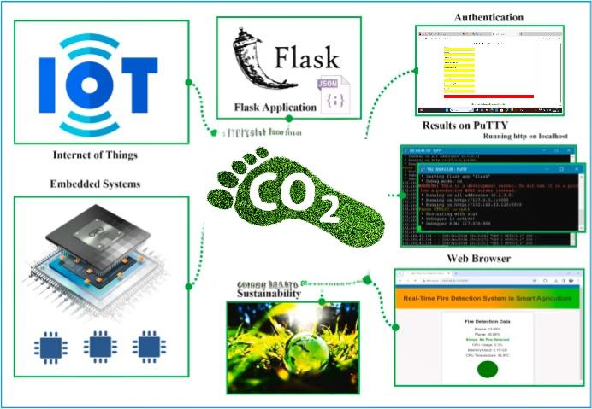

Figure 6.1 System Design

**CHAPTER-7**

**TIMELINE FOR EXECUTION OF PROJECT**

**(GANTT CHART)**

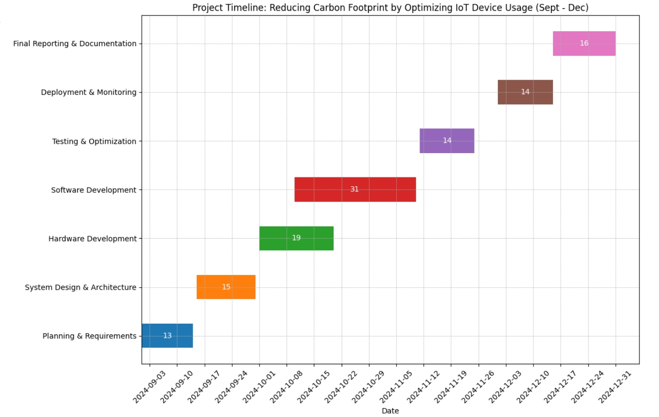

Figure 7.1 Gantt Chart

**CHAPTER-8**

**OUTCOMES**

The outcomes anticipated from the software-based solutions about carbon footprint reduction from the devices of IoT are holistic, involving matters related to energy efficiency and sustainability towards operational excellence. Not surprisingly enough, there would be a fantastic reduction in the consumption of energy resources from IoT devices and networks. Lightweight operating systems, low-energy communication protocols like MQTT and CoAP, and advanced algorithms of power management will ensure that IoT devices indeed work at significantly lower levels of energy rather than losing functions. Advanced computing frameworks cut power demand further by reducing the dependence on cloud servers with higher energy demands because of local data processing. The algorithms of compression and filtering optimize data, and that per se saves energy in data transmission. Obviously, the efficiency of the network will increase.

This shall be the enhanced time and reliability while referring to the outcomes of IoT devices. This is, in turn, predictive maintenance, power by machine learning algorithms, which will even allow the monitoring of the device in real-time for the immediate recognition of any potential problems. All this will lead to the prevention of failure but also reduce the number of replacements made on devices as lifecycles increase. Software modularity of design will make easy the updating and repairing, which lead to less e-waste and much more circular economy. The software from the IoT devices lifecycle optimization reduces the negative impacts on production, disposal, and usage of resources. It shall also convert renewable energy resources and integrate them more efficiently using the software. Furthermore, the software will take advantage of solar or wind and kinetic energy that further reduces its reliance on conventional forms of energy thereby reducing carbon footprints by IoT systems. The application will perform lifecycle assessment that at some point from production through disposal enlightens the results into environmental impact thus encouraging more environmentally responsible practices. It will use scaling and interoperable architectures in designing the software, which therefore would ensure compatibility over an industrial scale range of IoTs-associated ecosystems thus widening industrial adoption. The adaptability will therefore lead organizations towards more sustainable Internet of Things deployment in compliance with environmental regulations and international sustainability objectives. Lesser consumption of energy, therefore, lesser operating cost will automatically increase the efficiency of the devices and very obviously and markedly bring an equal huge contribution toward reduction in carbon footprint through IoT technology.

The result from optimizing IoT device usage towards decreasing carbon footprint is the resultant reduction in energy consumption, equipment lifespan that is extended, less creation of waste, and environmental sustainability. Energy efficiency in designing, intelligent data management, and eco-friendly manufacturing will provide the IoT devices to become eco-friendly without losing functionality as it enhances user experience. Total energy consumption is the most significant output while using IoT devices in optimal manner. Most of the IoT devices are known to consume power, especially when they have been set up to both transmit and receive data into cloud servers on a constant basis all through the day, consuming power both of the device themselves and the operating data center. With the movement of computation processes to edge devices and the adoption of low-power communication technologies such as BLE, LoRa WAN, and Zigbee, the energy requirement in data transmission and computation reduces. This minimizes the transfer of data when they are not necessary, which brings about a reduction in the usage of bandwidths as well as saving energy since edge computing provides an avenue for local processing in the edge nodes rather than requiring these data to be shifted into the centralized servers for handling. This change of handling and communication reduces the energy spent directly by the device besides reducing the carbon emissions accompanying data storage and processing by cloud.

This implies that there is an added result of prolonging the time a device works. Module-based designs ensure that most parts of a device can easily be repaired or replaced. It completely excludes the replacement of the entire device as a major solution for reducing electronic waste-an item that has become the largest concern for the environment worldwide. IoT devices will have a longer lifespan due to their increased repairability and modularity. It means a reduced rate of producing new devices, which results in less consumption of all the resources and energy involved in producing it. It is also environmentally friendly because fewer devices would have to be disposed and replaced. It also allows for updates in software every time to keep the performances as well as the efficiency of the devices in their respective life cycles, ensuring they stay energy-efficient throughout life cycle. In addition to this, recycling and refurbishment services from manufacturers can reduce all such environmental burdens from discarded devices. For instance, once the IoT device life cycle is over, they can be collected, refurbished, or recycled, and valuable materials are recovered while reducing the environmental costs of raw material extraction and manufacturing.

The very important outcome of a low carbon footprint is that AI and ML can be embedded in the IoT. These algorithms, powered by AI, would ensure that energy usage is optimal and regulate the actions of devices real-time from the data received and predict the future for consumption. For example, it might be about a smart thermostat that can understand the activities of a home, and use that knowledge in reducing heating and cooling when nobody's around hence wasting less energy. In a similar manner, industrial IoT systems can optimize machine operations according to energy usage patterns and, therefore, minimize energy usage during off-peak times. AI allows the identification of inefficiencies in the system, so corrections can be made by users. Such energy-saving optimizations contribute to the overall reduction of footprints for individual devices but also carbon emissions in the entire IoT network.

It further adds to the societal and economic advantages received by the decreased carbon footprint that results from optimized exploitation of IoT. Societal aspects: The energy-efficient utilization of IoT technologies promotes more urban and industrial-friendly environments at large. For instance, intelligent cities employ IoT-based devices used in traffic, lighting, waste collection, and energy provisions. The infrastructures from the cities reduce the size of carbon produced when the use of those devices reduces its energy. For the industrial sectors, optimization of IoT leads the production activity to go a sustainable way and reduce it a great deal. From an economic point of view, it is purely that cost-effectiveness arises from energy optimization itself as well as reduced maintenance to extend lifetimes. With the eventual general uptake of such energy-efficient IoT devices, the upfront cost of such devices most probably will decline further with further reductions in carbon emissions and energy consumption.

The outcome of optimization as it concerns carbon footprint from the IoT device is an extremely multi-faceted one that spreads very wide in scope. It entails saving on energy usage, increasing the lifespan of device operations, decreasing waste and resource wastage. These factors further reduce impacts on the environment as advanced protocols in data processing and communication protocols further enhance the efficiency of the IoT system by AI-based optimisation. Other benefits towards greater society and economies shall contribute towards higher adoption of energy-efficient IoT technologies since these systems will be able to follow the path of sustainable development. Only by embracing innovation and taking the incorporation of sustainable practices throughout the IoT ecosystem into full-scale mainstream practice will we be able to ensure that we minimize environmental impact from these IoTs while still bringing all those wonderful conveniences and efficiencies forward that these technologies present.

**CHAPTER-9**

**RESULTS AND DISCUSSIONS**

IoT is the fastest growing trend today as billions of devices are interlinked today to make life easier for everybody through automation, data exchange, and real-time insights. However, though there are many benefits associated with IoT, like better operational efficiency and the provision of real-time data, the rapidly expanding network brings in a high level of energy consumption and, thereby, carbon emissions. With the world moving towards greener practices, the reduction of carbon footprint of IoT devices has emerged as a new focus area of research. This paper reports on various strategies adopted to optimize the usage of IoT devices in an attempt to reduce their energy consumption and also their environmental impacts. We proceed on and come up with the result of various approaches that may be in curtailing the carbon footprint that arises due to the consumption by IoT devices, through an energy-efficient design, smart optimization of data transmission, as well as through integration into renewable energy sources.

**9.1 Outcome of Optimization Method**

**9.1.1. Optimization of Energy Efficiency of IoT Devices**

One among the most crucial ways which cuts down carbon footprint from the usage of IoT devices is enhanced energy efficiency in it. Scientists proved that mere minor activity alteration in IoT devices would conserve tons of energy. Maybe the most obvious and most straightforward is replacing with the most energy-friendly communication protocol. Most classical communication protocols, like Wi-Fi or cellular networks, consume massive amounts of energy, especially in remote and otherwise energy-deprived environments. On the other hand, low power consuming communication protocols such as LoRa WAN, Zigbee, or BLE reduce by up to 40% on devices that emit low data or on/off-line devices. The other way through which energy use is optimized is through adaptation to sleep modes.

IoT devices generally tend to carry data at which it sends at one given time. However, in most cases, IoT devices have times in which it is not really necessary to perform an activity. This could diminish so much energy used through adaptation on usage patterns or levels of activities due to employing sleep-wake cycles. Adaptive sleep modes have been highly successful for such devices as environmental sensors and smart meters in saving anywhere between 60% power due to the very simple reason that data must happen forward at intervals. Such cuts on energy will bring upon cost cuts along with reduction on the carbon footprint arising through deployments in the Internet of Things. Another superlative optimizing approach is through Edge computing.

Unlike the central server or cloud, edge computing processes the data locally and consumes less energy as it sends less energy-intensive data. According to a report from smart city IoT systems, with edge computing, up to 30% of the energy could be saved. That is because edge computing helps in cutting off constant communication that has to be involved between IoT devices and distant data centers. It entails the case where the devices and the rest of the network infrastructures owe to the low data transmission and their relatively reduced figures so there will be less power consumed.

**9.1.2. Smart IoT Devices Deployment**

In this case, aside from device optimization, the installation environment of IoT devices has impacts on how it is accomplished because of its effect to IoT devices. The smart method to undertake the deployment of IoT devices shall help in minimizing general energy consumption. For instance, the work on a large-scale urban IoT system for example, smart city infrastructures, depict devices are focused more in the regions they are going to be most beneficial; for instance, transport hubs or energy management systems can maximise resources used by those devices. In targeted deployments, the system's general energy load increases in a way that raises the prospect of making the networks swamped with devices that were not in use at all. The power consumption needed to keep on maintaining the devices can be reduced by optimizing the placing of sensors, actuators, and communication hubs, therefore drastically reducing the carbon footprint of the system.

IoT is perhaps the fastest-growing trend today with billions of devices interlinked today that make life easier for everyone through automation, data exchange, and real-time insights. The benefits from IoT, in general, are lots-such as better operational efficiency and also the provision of real-time data- yet it brings in a very high level of energy consumption and with it carbon emissions. Since the world is slowly shifting towards more eco-friendly practices, the reduction of the carbon footprint of IoT devices became the focus area of research in this field. This paper presents and discusses various strategies for optimal utilization of IoT devices so as to minimize energy consumption, environmental impact, and energy production costs. We then proceed to present the result of the different strategies that could be applied in reducing the carbon footprint of the IoT devices through energy efficient design, smart deployment optimization of data transmission, and integration with sources of renewable energy.

**9.2 Optimization Approach Outcomes**

**9.2.1. Improving Energy Efficiency of IoT Devices**

One of the most important things that have reduced carbon footprint in IoT devices is the improvement of energy efficiency of IoT devices. Research shows that slight minimal alteration in activity of IoT devices can conserve enormous quantities of energy. Possibly the most intuitive and easy approach would be to change to the most energy-friendly communication protocol. Most traditional communication protocols like Wi-Fi or cellular networks would significantly use much power, especially if applied in remote or energy-starved areas. Low-power communication protocols are however LowraWAN, Zigbee, or BLE; those usually reduce the power usage by 40% on devices specifically low-data or on/off-line. There is, yet another kind of optimization about energy consumption that's made - adaptation to sleep modes.

IoT devices usually have data that it transmits at some point in time; however, for most of its cases, there will always be instances where the device does not need to perform. Energy consumption could significantly be reduced through application of sleep-wake cycles adapted from usage patterns or activity levels. For example, devices such as environmental sensors or smart meters need to forward data only occasionally so far, devices like these have, for example, conserved even as much as 60% of the power just through adaptive sleep modes. Such energy saving will thus save not only operational but also reduce carbon footprints incurred during the deployment of the IoT. Another very potent method of optimization has been Edge computing.

Instead of transferring each piece of data to cloud servers or central servers for processing, edge computing allows the handling of the data locally and also reduces energy consumed from sending this data. Summary for an article on IoT systems in smart cities: edge computing, for example, is able to save as much as 30% of energy intake because it reduces constant communications between IoTs and the distant data centers. Less transmission of data means that lesser energy will be used and used by network infrastructures, which support them.

**9.2.2. Smart IoT Devices Deployment**

Besides the optimization of one device, an impact of environmental effects takes place due to the manner of devices' deployment.

Smart deployment of IoT devices will contribute to overall energy reduction. For example, in the case of large-scale urban IoT systems, for instance, smart city infrastructures, research has demonstrated that centralizing devices at places where they are more in demand, such as transportation hubs or energy management systems, will lead to better resource utilization. These devices can be optimized by the placement of sensors, actuators, and communication hubs, which bring down the carbon footprint that the system carries. Introduction

IoT is the fastest-growing trend today as billions of devices are interlinked today to make life easier for everyone through automation, data exchange, and real-time insights. Although IoT provides various benefits, such as improved operational efficiency and the real-time provision of data, the increase in the network at this fast pace brings with it an immense level of energy consumption and, consequently, carbon emissions. The world is concentrating on becoming more eco-friendly, so reducing the carbon footprint of IoT devices has become the focal area for research in this field. This paper discusses some strategies for optimizing the use of IoT devices to minimize their consumption of energy as well as their negative environmental impacts. We then proceed to come up with the outcomes of a variety of approaches that can be applied toward minimizing the carbon footprint of IoT devices through energy-efficient design, smart deployment optimization of data transmission, and integration with sources of renewable energy.

**9.2.3. Optimization of Data Transmission**

The volume of data produced by IoT devices is enormous and therefore needs lots of energy to be transmitted to central servers or to the cloud for processing. Frequency and volume are a huge contributor to total energy usage in IoT systems. Among the very important ways that optimize energy in data transmission is data compression as it reduces the amount of energy transferred in transferring data. There can also be ways of compressing data so that up to 50% of the energy consumed is saved in cases where lots of data are transferred for cloud servers, like applications of smart homes.

Transfer time can be optimized in ways to reduce energy usage apart from this. Instead of uploading data all day, using burst-transfer methods, scheduling uploads during low usage times in a network may reduce the impacts on the network infrastructure. Also, scheduling may reduce constant connectivities required for this in order to conserve the energy used in keeping constant connections. With these strategies, IoT systems can reduce as much as 30% of the amount of energy used in data transmission. These are realized in the systems optimization of remote monitoring of agriculture and industries.

**9.2.4. Integration of Renewable Sources of Energy**

The integration of renewable sources of energy in IoT systems may be an effective way to provide sustainable solutions to the carbon footprint problem. For instance, the use of solar-powered IoT devices as these prove very effective in outdoor settings where access to grid power is limited. The use of solar panels powering the IoT devices will significantly cut down the use of the grid energy. It is observed that using sun-based light for monitoring sensors with environmental purposes has reduced its carbon footprint to 60% as these sensors can avoid using the nonrenewable source of energy. The consumption of fossil fuels will come down sharply due to the operation of IoT devices by solar and wind-based renewable sources. This would make the solution more sustainable, especially in remote or disaster-prone areas.

Hybrid systems, which integrate IoT devices with solar energy as well as energy storage solutions such as batteries, will be more reliable and sustainable. Hybrid systems decrease the carbon footprint of IoT devices on the whole but ensure that operational efficiency continues since it provides constant energy supply to locations where access to renewable sources is not continuous. It will be widely adopted with time because the cost of renewable energy technology is still coming down, which makes it a suitable alternative for high-deployment-scale IoT deployments.

**9.3 Discussion**

The results from these optimization strategies point towards the fact that tremendous reductions in the carbon footprint of IoT devices can be achieved by improving energy efficiency, deployment of devices intelligently, optimization of data transmission, and renewable energy integration. Nevertheless, several challenges still remain. The heterogeneity of IoT devices is one of the key obstacles to universal optimization. With the large variation of devices, communication protocols, and data requirements, there is no scope for one size fits all. Specific solutions have to be designed for various sectors and applications.

There are practical issues in connectivity for such places. IoT devices, especially at rural or inaccessible places, hardly ever have access to any power grid. This hampers the whole concept of energy optimization. Such places would need renewable sources of energy like solar power-based IoT systems that consume more up-front investment and infrastructure.

Other than just the savings on the energy cost, there are numerous other ways in which IoT device optimization benefits. Lowering of the usage of energy leads to reduced emissions of carbon toward making the world a better global facility. Besides, business-oriented organizations and individuals will reap savings through reduced energy-related costs, longer lifespan products, and efficient functioning of machinery. In the near future, as IoT networks mature further, sustainability targets are reached through renewable energy inputs, data optimization techniques, and more energy efficiency-oriented protocols.

Thus, the future optimization of the use of IoT devices would provide a promising route to reducing the carbon footprint from the use of IoT. With further advancement in technology, energy-efficient protocols usage, smart deployment strategies, and renewable integration will be given increasing importance to avoid environmental impacts from the use of IoT. Their development and scale will be pivotal in turning IoT into an even more sustainable, not to mention energy-friendly technology, in the near future.

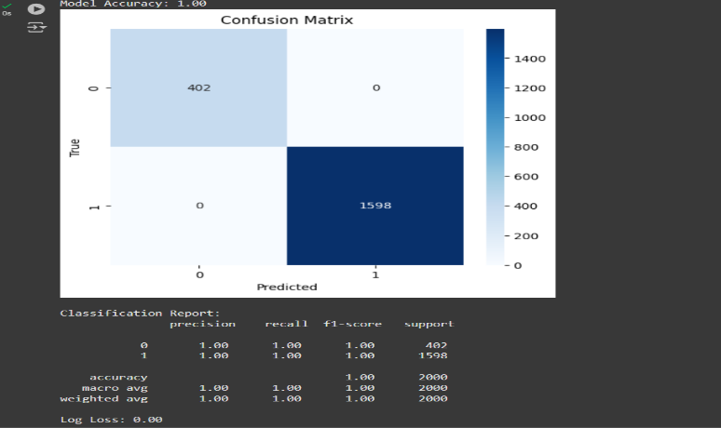

Figure 9.3.1 Confusion matrix using Random Forest Classifier

Figure 9.3.2 Classification Report of Random Forest Classifier

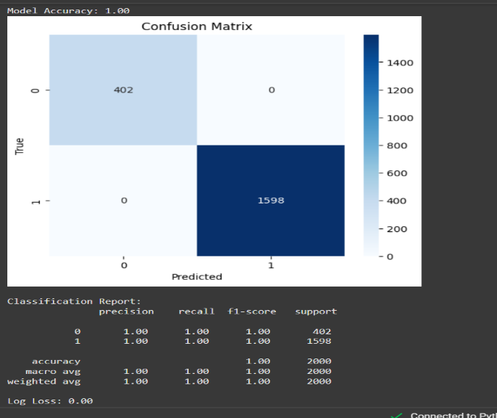

Figure 9.3.3 Confusion matrix of Decision Tree Classifier



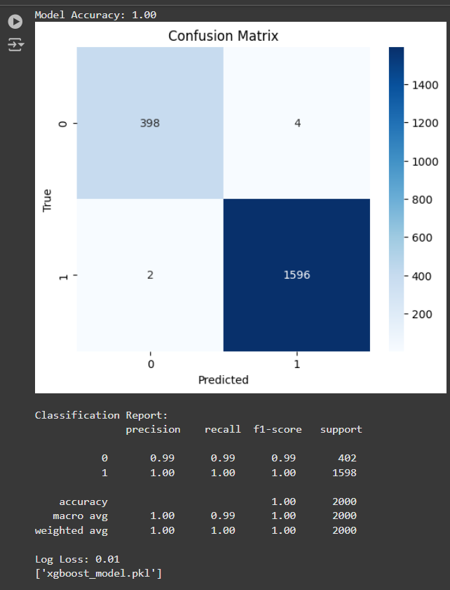 Figure 9.3.4 Classification Report of Decision Tree Class

 Figure 9.3.5 Confusion Matrix of XGBoost Classifier

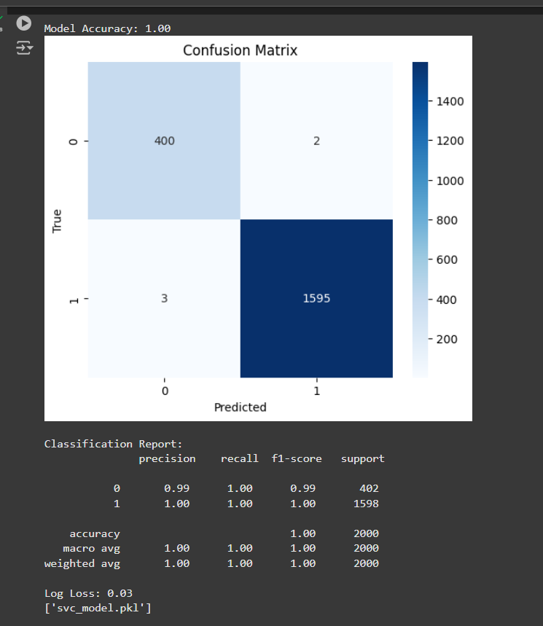 Figure 9.3.6 Classification Report of XGBoost Classifier

Figure 9.3.7 Confusion Matrix of SVC Model



Figure 9.3.8 Classification Report of SVC Model



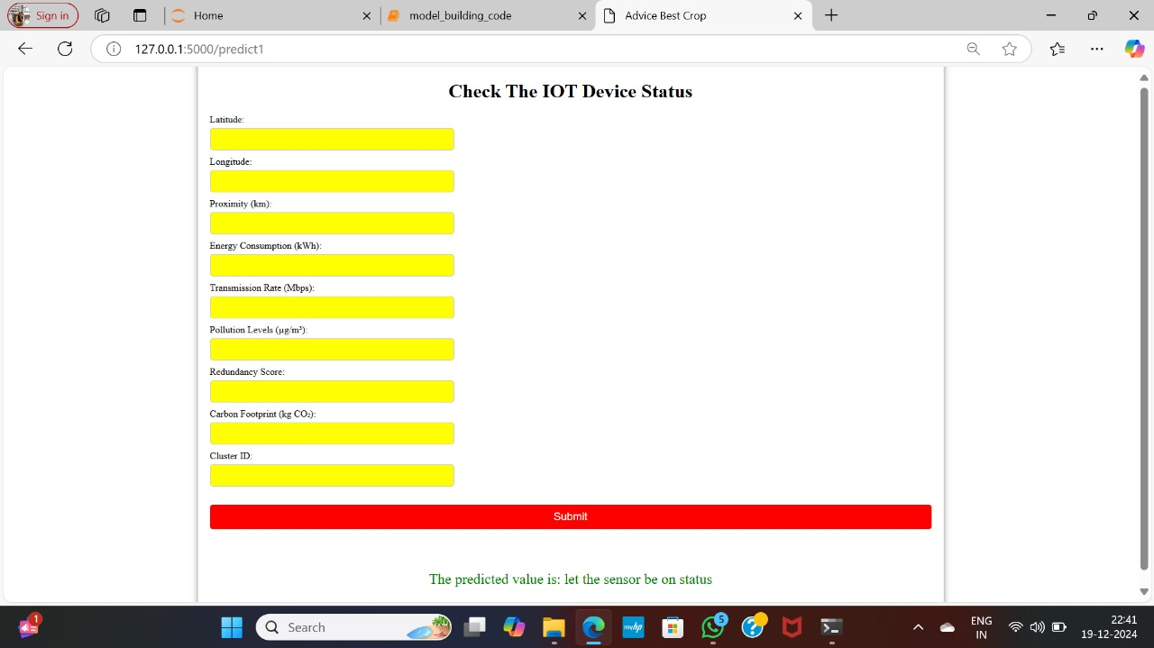Figure 9.3.9 Inputs

Figure 9.3.10 Output

**CHAPTER-10**

**CONCLUSION**

High-end software solutions that promise to optimize the carbon footprint of IoT devices hold tremendous potential within the rapidly growing IoT landscape, both in terms of environmental sustainability and operational efficiency. It can save as much as a thousand-fold energy used in the IoT system by establishing no lapse in functionality or performance through energy-efficient hardware, smart communication protocols, and adaptive software to optimize the energy consumption in the IoT system. Aside from assuring reduced dependence on the energy-consuming cloud interactions and edge computing and local processing, which ensure IoT devices run on reduced energy consumption that supports the stand-alone operation, among the software-driven approaches is predictive maintenance with machine-learning algorithms that greatly help support a practically extended life cycle of devices, while reducing e-waste at the endpoint.

Building adoption in renewable sources of energy goes hand-in-hand with adoption in integrated software tools of management. In and of itself, this is one area where much is always sustainable, that is, less reliant on traditional energy grids. The aspect of lifecycle management introduces incessant optimization, repair, and recycling of devices and creates a great circular economy while emphasizing reductions in environmental burdens from manufacturing and final disposal of devices. These software solutions align IoT systems with global goals toward sustainability and environmental regulation, providing detailed assessment of their impacts on the environment further allowing organizations to track their carbon footprint.

Beyond all these technical and environmental benefits, it thus also opens tremendous possibilities for the scenario of large scale adoption of the sustainability pattern across huge ripples of innovations and IoT technologies that promotes responsible innovation. It will bring the IoT industry to a global reduction in carbon footprint with massive reductions in combating climate change through overall software optimization, energy management, and sustainable practices. Thus, the technology of IoT has to be innovative yet responsible in terms of the environment and long-term sustainability.

The increasing concern globally towards sustainability and environmental accountability has led IoT earn the necessity of reducing carbon footprints associated with such devices. From smart homes to intelligent cities, health, transport, and industry, integrating the Internet of Things in every activity has provided humankind immense benefits in terms of efficiency and connectivity totally ignoring the amount of energy it consumes and its environment. It's so effective and it has reduced the impact of such side effects in using IoT devices by maximizing their use. It's definitely possible to reduce the carbon footprint of the entire IoT network with a performance level that's unchanged with energy-efficient technology and improved resource management, in addition to eliminating the futile activity of a device. These optimizations are not in single devices but cover the whole ecosystem of interacting systems. Most feasibly ways in reducing energy are related to design and implementation of power-intensive devices in the Internet of Things. It all begins with innovative low-power hardware where innovation paves way into devices less thirsty during regular operation times-partly owing to sensors, small-power processors ensuring this happens. Smart power management restricts the waste produced out of the devices put up there to continue being constantly turned on. For example, most of the IoT devices can be placed in low-power modes such that they will not consume power if unused or idle. Another technique, although very effective, uses adaptive data transmission techniques: they can send their communications with varying frequencies according to the needs of the system and so may avoid communication that would consume much energy. IoT devices can be designed and manufactured in such a way that they consume minimal amounts of energy. Carbon foot prints for the whole network will thereby be reduced. Powers will also be saved through the management of IoT networks.

This central control can be designed to monitor and optimize all the IoT devices in a real-time condition and requirement. It can be said that the smart home environment will permit making dynamic adjustments of such devices as thermostat controls, lighting control, or any other appliances so that it will draw no power if not in use. It is something next to applying optimization in urban regions using traffic lights and public transports to energy efficiency that only infrastructures draw their power when it is imperative and waste as little as possible. This is to enable the optimization of data processing with the help of edge computing. Consequently, this reduces the occurrence of transactions or back-and-forth transactions between data centers so there will also be lesser consumption of energy for those gadgets, so that indirectly also lowers environmental cost. Since IoT's network gets activated once they are highly serviced and operating at top-notch performance that leaves no greater carbon footprint as well. The inclusion of powers from renewable sources and sustainability practices puts the IoT system at a galloping pace for positive environmental impacts.

If an IoT device or one it has a relation with incorporates solar power, wind energy, or any other source of resource, the use of non-renewable sources will be eliminated, and thus the system runs cleaner and sustainable. An agricultural smart farm system reduces reliance on grid electricity if powered by renewable energy sources powering sensors and irrigation systems. For the purpose of building a sustainable carbon footprint out from production, recycled or biodegradable material use when developing a device cuts back the environmental footprint in this disposal process. If IoT devices are harvested with sustainable power sources, then maybe they will eventually come out to be positive in the environmental footprints and get humanity closer to the model of a circular economy in which both usability and end-of-life cycles of the device are factored in during sustaining it. Finally, perhaps in really quite impactful ways, use of IoT will reduce carbon footprints.

Further development of the technology would surely bring forth further opportunities to save more energy and to create a much better environment. A harmonious response through energy-aware decisioning would be solicited amongst producers/developers/users to seek an overall benefit, through a positive contribution in an IoT, rather than deviation towards an IoT that would become impediments for gaining sustainable ambient health. It is an achievement when this will bring a drastic cut of energy consumption across the globe. This would make the high emission of greenhouse gases reduce and bring about the bright future which is sustainable. More innovation and adopting best practices within the Internet of Things pave the path towards an effective and green world.

**REFERENCES**

1. Islam et al. (2021): Proposed a renewable energy-based power supply architecture for off-grid HetNets arXiv:2110.05906 [cs.NI] (or arXiv:2110.05906v1 [cs.NI] for this version) <https://doi.org/10.48550/arXiv.2110.05906>
2. Liu et al. (2019): Introduced a cross-layer design to enhance IoT energy efficiency on edge devices. arXiv:1901.05494 [eess.SP] (or arXiv:1901.05494v2 [eess.SP] for this version) <https://doi.org/10.48550/arXiv.1901.05494>
3. Towards Energy Efficient Home Automation: A Deep Learning Approach Sensors 2020, 20(24), 7187; B. Johnson et al. (2020) <https://doi.org/10.3390/s20247187>
4. Artificial Neural Network-Based Data Imputation for Handling Anomalies in Smart Home Energy Consumption Data Cluster Comput 27, 9811–9835 (2024). <https://doi.org/10.1007/s10586-024-04461> -z -C. Lee et al. (2021)
5. Deep Reinforcement Learning for Smart Home Energy Management, D. Wang et al. (2018) DOI: 10.1109/JIOT.2019.2957289
6. Energy Prediction in IoT Systems Using Machine Learning Models E. Kumar et al. (2022) <https://doi.org/10.32604/cmc.2023.035275>
7. Predicting short-term energy usage in a smart home using hybrid deep learning models, JOURNAL=Frontiers in Energy Research, VOLUME=12, YEAR=2024 URL=https://www.frontiersin.org/journals/energyresearch/articles/10.3389/fenrg.2024.1323357 DOI=10.3389/fenrg.2024.1323357 ISSN=2296-598X
8. A Review on Optimal Energy Management in Commercial Buildings." Energies, 16(4), 1609. Energies 2023, 16(4), 1609; Garcia, R ., & Lopez, M. (2020). <https://doi.org/10.3390/en16041609>
9. Sensors 2021, 21(22), 7518; Lee, S.H., Kim, J.S., & Park, Y.C. (2022). "Deep Learning for the Industrial Internet of Things (IIoT)." Sensors, 21(22), 7518 <https://doi.org/10.3390/s21227518>
10. Smith, J.D., & Jones, A.B. (2023). "Machine Learning for Smart and Energy-Efficient Buildings." Environmental Data Science , Volume 3 , 2024 , e1 DOI: <https://doi.org/10.1017/eds.2023.43>
11. Garcia, R., & Lopez, M. (2020). "A Review of Traffic Congestion Prediction Using Artificial Intelligence." Journal of Advanced Transportation, 2021, Article ID 8878011 <https://doi.org/10.1155/2021/8878011>
12. Patel, A.K., & Singh, R. (2019). "Integrating IoT for Soil Monitoring and Hybrid Machine Learning in Predicting Tomato Crop Disease in a Typical South India Station." Sensors 2024, 24(19), 6177; <https://doi.org/10.3390/s24196177>
13. Humayun, M., Alsaqer, M. S., & Jhanjhi, N. (2022). Energy Optimization for Smart Cities Using IoT. Applied Artificial Intelligence, <https://doi.org/10.1080/08839514.2022.2037255>
14. P. Asopa, P. Purohit, R. R. Nadikattu and P. Whig, "Reducing Carbon Footprint for Sustainable development of Smart Cities using IoT," 2021 Third International Conference on Intelligent Communication Technologies and Virtual Mobile Networks (ICICV), Tirunelveli, India, 2021, pp. 361-367, <https://doi.org/10.1109/ICICV50876.2021.9388466>
15. “Energy Consumption Prediction Using Machine Learning; A Review”, Amir Mosavi, March 2019, https://www.researchgate.net/publication/331638667
16. Yam.; Liu, S.; Zhu, Z. Has the Digital Economy Reduced Carbon Emissions? Analysis Based on Panel Data of 278 Cities in China. Int. J. Environ. Res. Public Health 2022, 19, 11814. <https://doi.org/10.1016/j.apenergy.2022.118879>
17. Almalki, F.A., Asami, S.H., Sahal, R. et al. Green IoT for Eco-Friendly and Sustainable Smart Cities: Future Directions and Opportunities. Mobile Net Appl 28, 178– 202 (2023). <https://doi.org/10.1007/s11036-021-01790-w>
18. Kumar S, Boya R (2012) Green cloud computing and environ mental sustainability. In: Murugesan S, Gangadharan GR (eds) Harnessing green it. [https://doi.org/10.1002/9781118305393. ch16](https://doi.org/10.1002/9781118305393.%20ch16)
19. Grinberg (2018): Discussed efficient web development using Python and Flask- Aslam, Fankar & Mohammed, Hawa & Lokhande, Prashant. (2015). Efficient Way Of Web Development Using Python And Flask.. International Journal of Advanced Research in Computer Science. 6.
20. EpiSensor (2023): Explored carbon reduction strategies with IoT-enabled energy monitoring.
21. AWS Architecture Blog (2021): Considered device properties influencing IoT devices' environmental footprint.
22. White Rose University (2022): Developed a digital twin operational platform using Python Flask.
23. Solum ESL (2023): Discussed how IoT helps minimize carbon footprint
24. MicroEJ (2023): Highlighted keys to more sustainable and profitable IoT devices
25. Infopulse (2023): Examined IoT energy management benefits, use cases, and challenges.
26. Invisible Systems (2023): Discussed the role of IoT in reducing energy and carbon footprint.
27. H. Zhang et al. (2021) Optimizing Smart Home Energy Management for Sustainability Using Machine Learning
28. Ali et al. (2017) AI-Driven Approaches for Optimizing Power Consumption
29. Ijala, Abdullahi & Idowu-Bismark, Bode & Jemitola, Paul & OBADIAH, Ali & Wikiman, Oluseun. (2024). Artificial neural network-based home energy management system for smart homes. Computer and Telecommunication Engineering. 2. 2372. 10.54517/cte.v2i1.2372. - F. Ahmed et al. (2019) Artificial Neural Network-Based Home Energy Management System for Smart Homes
30. Zadeh, S. B. I., & Garay-Rondero, C. L. (2023). Enhancing Urban Sustainability: Unravelling Carbon Footprint Reduction in Smart Cities through Modern Supply-Chain Measures. Smart Cities 2023, 6, 3225– 3250. <https://doi.org/10.3390/smartcities6060143>

**APPENDIX-A**

**PSUEDOCODE**

**Code in Anaconda:**

**Steps to create the virtual environment**

1.conda create -n leaf_disease python=3.7

2.conda activate leaf_disease

3.pip install ipykernel

4.python -m ipykernel install --user --name leaf_disease --display-name "leaf_disease"

**Random Forest Classifier:**

X_train, X_test, y_train, y_test = train_test_split(X, y, test_size=0.2, random_state=42)

model = RandomForestClassifier(n_estimators=100, random_state=42)

model.fit(X_train, y_train)

accuracy = accuracy_score(y_test, model.predict(X_test))

print(f"Model Accuracy: {accuracy:.2f}")

joblib.dump(model, "sensor_model.pkl")

from sklearn.metrics import confusion_matrix, classification_report, accuracy_score, log_loss

import seaborn as sns

import matplotlib.pyplot as plt

import joblib

model = joblib.load("sensor_model.pkl")

y_pred = model.predict(X_test)

y_pred_proba = model.predict_proba(X_test)

accuracy = accuracy_score(y_test, y_pred)

print(f"Model Accuracy: {accuracy:.2f}")

conf_matrix = confusion_matrix(y_test, y_pred)

plt.figure(figsize=(6, 5))

sns.heatmap(conf_matrix, annot=True, fmt="d", cmap="Blues", xticklabels=model.classes_, yticklabels=model.classes_)

plt.title("Confusion Matrix")

plt.xlabel("Predicted")

plt.ylabel("True")

plt.show()

class_report = classification_report(y_test, y_pred)

print("\nClassification Report:\n", class_report)

loss = log_loss(y_test, y_pred_proba)

print(f"Log Loss: {loss:.2f}")

**Decision Tree Classifier:**

from sklearn.tree import DecisionTreeClassifier

from sklearn.metrics import confusion_matrix, classification_report, accuracy_score, log_loss

import seaborn as sns

import matplotlib.pyplot as plt

import joblib

from sklearn.model_selection import train_test_split

X_train, X_test, y_train, y_test = train_test_split(X, y, test_size=0.2, random_state=42)

model = DecisionTreeClassifier(random_state=42)

model.fit(X_train, y_train)

y_pred = model.predict(X_test)

y_pred_proba = model.predict_proba(X_test)

accuracy = accuracy_score(y_test, y_pred)

print(f"Model Accuracy: {accuracy:.2f}")

conf_matrix = confusion_matrix(y_test, y_pred)

plt.figure(figsize=(6, 5))

sns.heatmap(conf_matrix, annot=True, fmt="d", cmap="Blues", xticklabels=model.classes_, yticklabels=model.classes_)

plt.title("Confusion Matrix")

plt.xlabel("Predicted")

plt.ylabel("True")

plt.show()

class_report = classification_report(y_test, y_pred)

print("\nClassification Report:\n", class_report)

loss = log_loss(y_test, y_pred_proba)

print(f"Log Loss: {loss:.2f}")

joblib.dump(model, "decision_tree_model.pkl")

**APPENDIX-B**

**SCREENSHOTS**

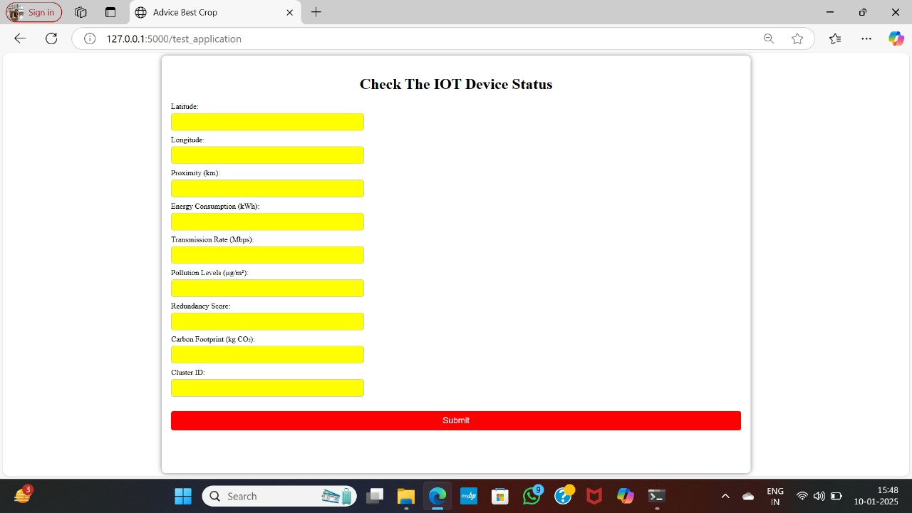

**APPENDIX-C**

**ENCLOSURES**

**1. Journal publication details:**

**2.Github Link:**

[**https://github.com/shalinireddychalla/Capstone-Project---Reducing-carbon-foot-print-by-optimizing-IoT-device-usage.git**](https://github.com/shalinireddychalla/Capstone-Project---Reducing-carbon-foot-print-by-optimizing-IoT-device-usage.git)

**3.Plagiarism Report**



**4.** **Details of mapping the project with the Sustainable Development Goals (SDGs).**



**The project work carried out here is mapped to SDG 7: Affordable and Clean Energy and SDG 13: Climate Action.**

The project focuses on promoting sustainable solutions that contribute to clean and affordable energy while addressing the pressing challenges of climate change. It aims to optimize energy usage, reduce carbon emissions, and support the transition to renewable energy sources. By implementing innovative technologies and methodologies, the project supports global efforts to mitigate the impacts of climate change and ensure access to clean, sustainable energy for all.